**MEMO**

|  |  |
| --- | --- |
| **To:** | WRIT 221 Instructor and Students |
| **From:** | River Kelly |
| **Date:** | September 18, 2020 |
| **Subject:** | Flatten the Curve; A COVID-19 Technical Definition |

The most common term used throughout the [COVID-19 pandemic](https://en.wikipedia.org/wiki/COVID-19_pandemic) is: ‘*Flatten the Curve*’. The term refers to the number of developed hospitalized cases over time in relation to the capacity of the healthcare system.

**In-Depth**: Looking at **Figure 1**, from The New York Time article ‘*Flattening the Coronavirus Curve*’ (Roberts), demonstrates the importance of *Flatten the Curve*. The dotted horizontal line represents the capacity by number of cases for which our health care system may be able to treat COVID-19 cases. The two curves labeled “Without Protective Measures” and “With Protective Measures” represent the two possible scenarios for which our healthcare system may encounter. Notice how the ‘red’ curve goes above the capacity of our healthcare system, while the ‘blue’ curve does not. The ‘red’ curve is also half the duration of time when compared to the ‘blue’ curve. The principle idea is that, with protective measures, we can increase the amount of time for which cases occur, effectively never breaching the capacity of our healthcare system.

**Figure 1** With and Without Protective Measures to Slow the Spread within Our Healthcare System Capacity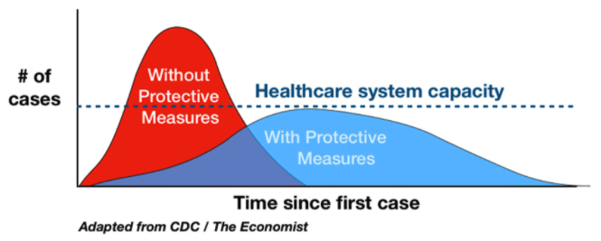

**Dissonance**: Referring back to (**Figure 1**), it is important to note that in each curve, the ‘red’ and the ‘blue’ or ‘Without Protective Measures’ and ‘With Protective Measures’, the number of infected cases stays the same. This is important because ‘*flatten the curve*’ does not mean ‘*crush the curve*’. By instituting measures like [lockdowns](https://en.wikipedia.org/wiki/Lockdown), may spread the number of cases out over time, but it is not intended to reduce the total number of cases. According to an article, ‘*Timeline: How Coronavirus got Started*’ (Schumaker), the United States declared a national emergency and a mandatory ‘15 days to slow the spread’ on March 13, 2020. That was over 170 days ago, and the lockdowns are still in place all over the country.

**Consequences**: “The COVID-19 lockdown is responsible for both the loss of economic activity and human lives.” (Berezon) Two independent studies attempt to measure the results of the lockdowns in terms of “years of potential life lost” (YPLL). Their findings conclude that the Coronavirus lockdowns are costing more life-years than it saves.

**Work Cited**

1. Roberts, Siobhan. “Flattening the Coronavirus Curve.” *The New York Times*, The New York Times, 27 Mar. 2020, [www.nytimes.com/article/flatten-curve-coronavirus.html](http://www.nytimes.com/article/flatten-curve-coronavirus.html).
2. Schumaker, Erin. “Timeline: How Coronavirus Got Started.” *ABC News*, ABC News Network, 28 July 2020, abcnews.go.com/Health/timeline-coronavirus-started/story?id=69435165.
3. Berezon, Alex. *Is the Coronavirus Lockdown Costing More Lives than It's Saving?* 27 May 2020, www.acsh.org/news/2020/05/27/coronavirus-lockdown-costing-more-lives-its-saving-14815.